RFCNN: Traffic Accident Severity Prediction Based on Decision Level Fusion of Machine and Deep Learning Model

In propose paper author is introducing new machine learning algorithm called RFCNN (Random Forest Convolution Neural Neural) to predict accident severity. In propose algorithm author combining two models called RF and CNN to enhance accident prediction accuracy and then compare its performance with various machine learning algorithms called Random Forest (RF), Ada Boost (AC), Extra Tree Classifier (ETC), Gradient Boosting (GBM), Voting Classifier (VC (LR+SGD)), CNN.

In all algorithms propose RFCNN is giving high accuracy, to train all algorithms author using USA Road Accident Dataset which consist of 47 features and author evaluating all algorithms performance using all 47 features (full features) and 23 selected features and for both dataset variants RFCNN is giving better accuracy.

Below screen showing dataset details

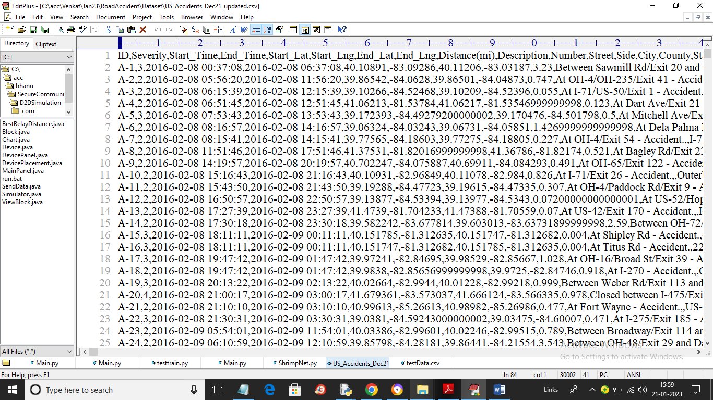

In above screen first row contains dataset column names and remaining rows contains dataset values and by using above dataset we will trained all algorithms and test their performance in terms of accuracy, precision, recall and FSCORE.

To implement this project we have designed following modules

1. Upload US Road Accident Dataset: using this module we will upload dataset to application and then find and plot missing values graph
2. Extract Full & Selected Features: using this module we will replace all missing values in the dataset with mean values and then separate full and selected features
3. Split Train & Test Data: using this module we will split dataset into train and test where application used 80% dataset for training and 20% for testing
4. Run Classifiers on Full Features: using this module we will trained all algorithms on full dataset features and calculate accuracy and precision values
5. Run Classifiers on Selected Features: using this module we will trained all algorithms on selected dataset features and calculate accuracy and precision values
6. Comparison Graph: using this module we will plot comparison graph between all algorithms on full and selected features
7. Comparison Table: this module we display comparison table of all algorithms
8. Predict Accident Severity from Test Data: using this module we will upload test data and then machine learning algorithm will predict severity of accident from test data

SCREEN SHOTS

To run project double click on ‘run.bat’ file to get below screen

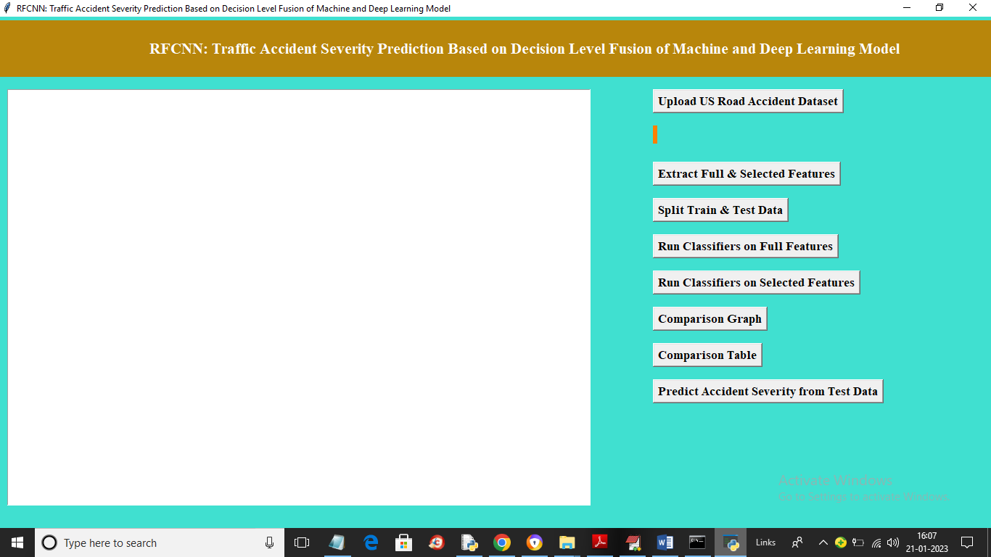

In above screen click on ‘Upload US Road Accident Dataset’ button to upload dataset and get below screen

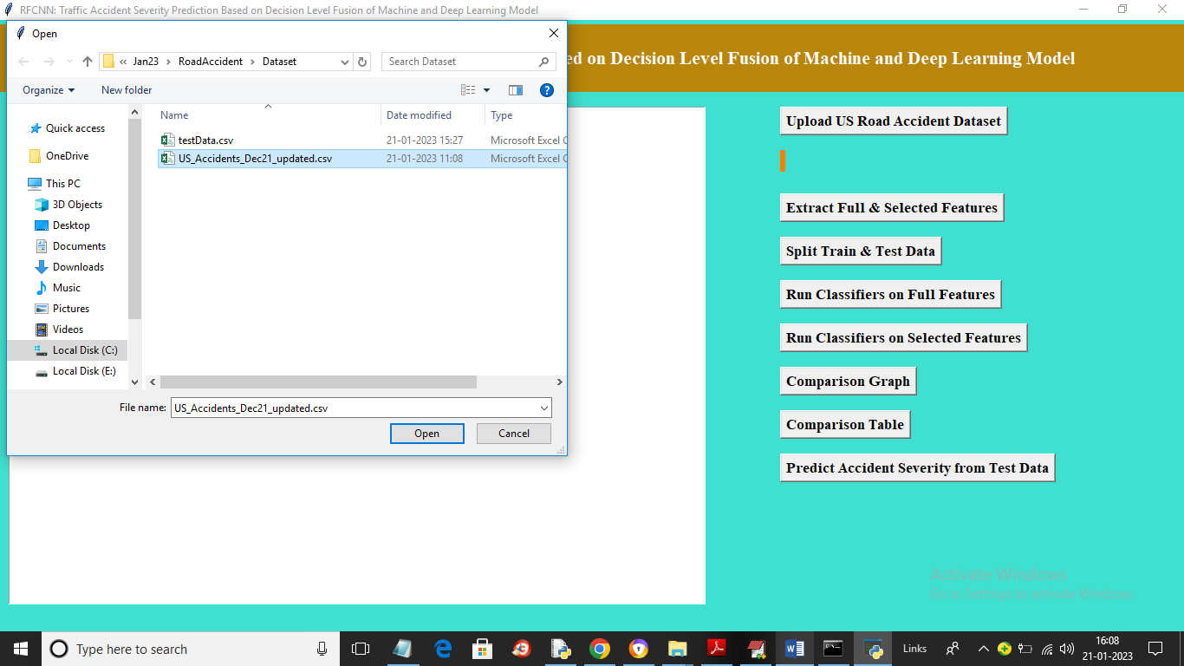

In above screen selecting and uploading dataset file and then click on ‘Open’ button to load dataset and get below output

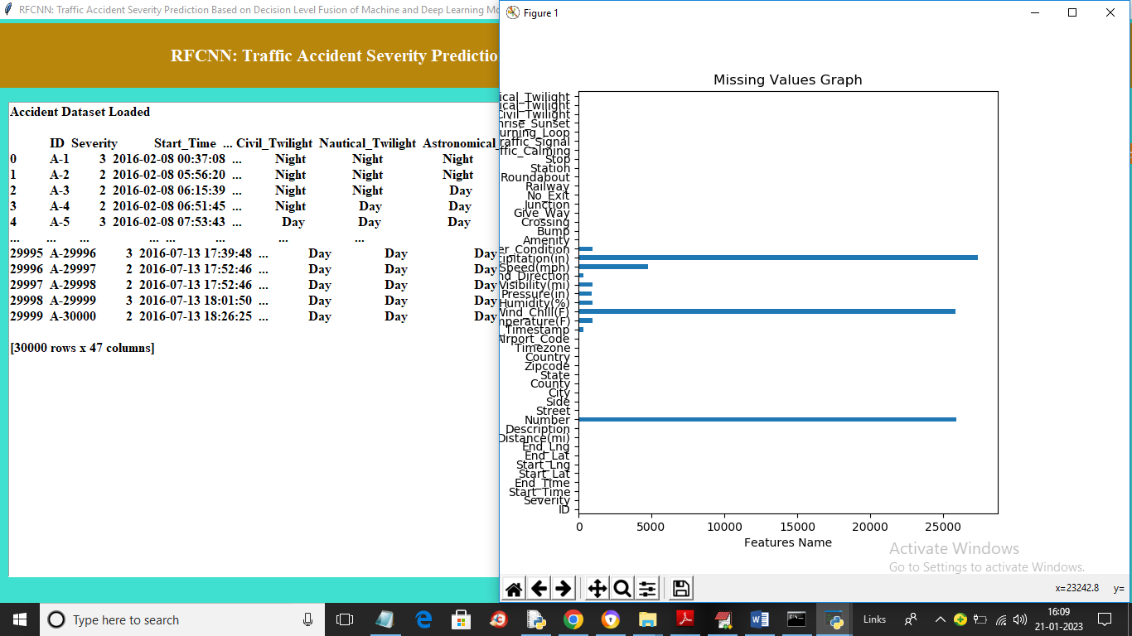

In above screen dataset loaded and in graph x-axis represents count of missing values and y-axis represents name of features. In above graph we can see dataset contains so many missing features and now click on ‘Extract Full & Selected Features’ button to replace missing values and then separate full and selected features dataset and get below screen

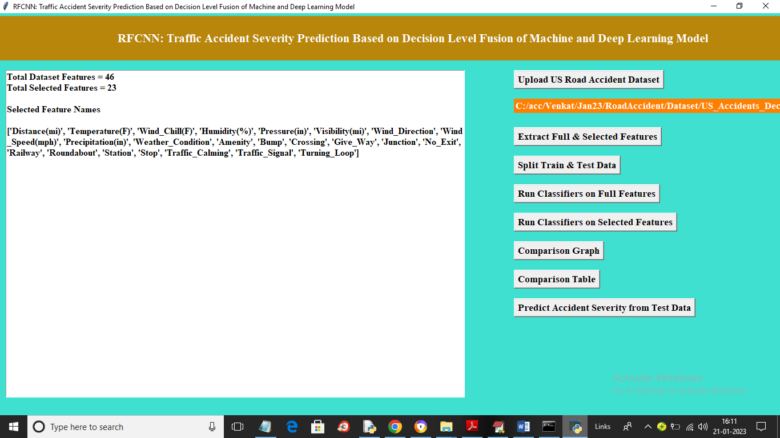

In above screen we can see dataset contains full column or features as 46 and then we selected 23 as selected features and the in next lines we can see names of selected features and now click on ‘Split Train & Test Data’ button to split dataset into train and test and get below output

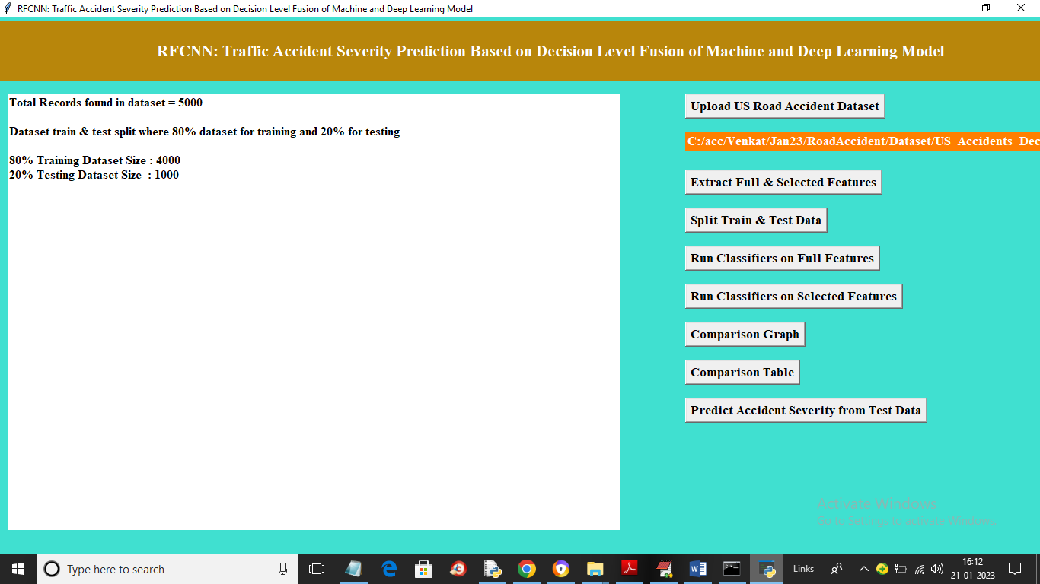

In above screen we are using 5000 records from dataset and application using 4000 records for training and 1000 for testing and now click on ‘Run Classifiers on Full Dataset’ button to train all machine learning classifiers on training data and test on testing data and get below output

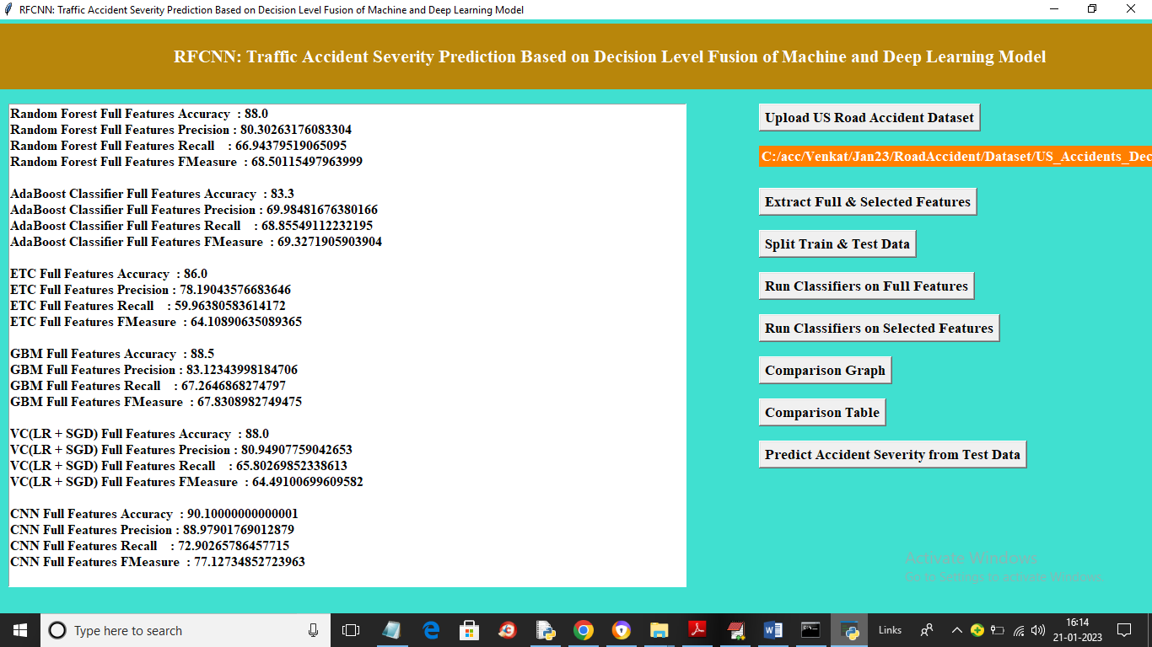

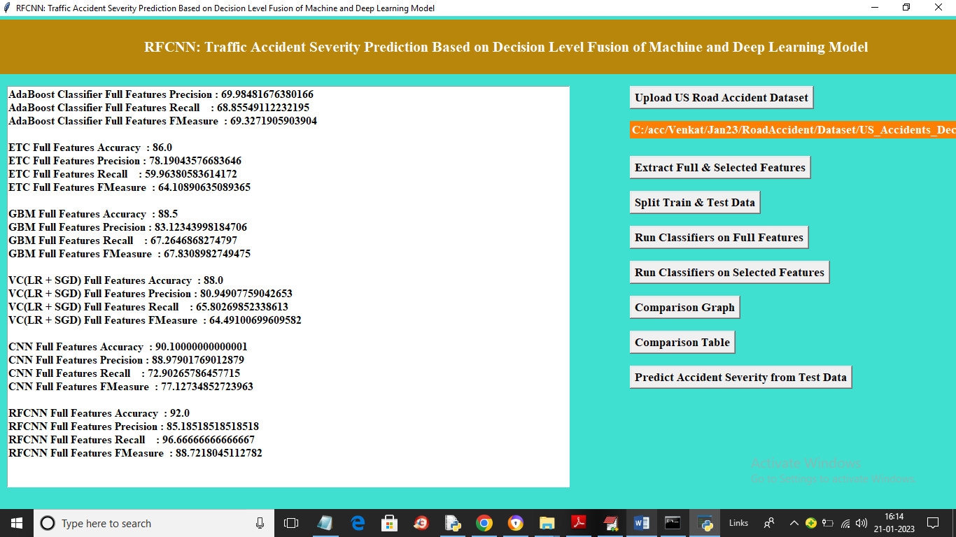

In above 2 screens we can see accuracy and other metrics on all features for all algorithms and we can see propose RFCNN got high accuracy as 92% and now click on ‘Run Classifiers in Selected Features’ button to train all algorithm on selected features and get below output

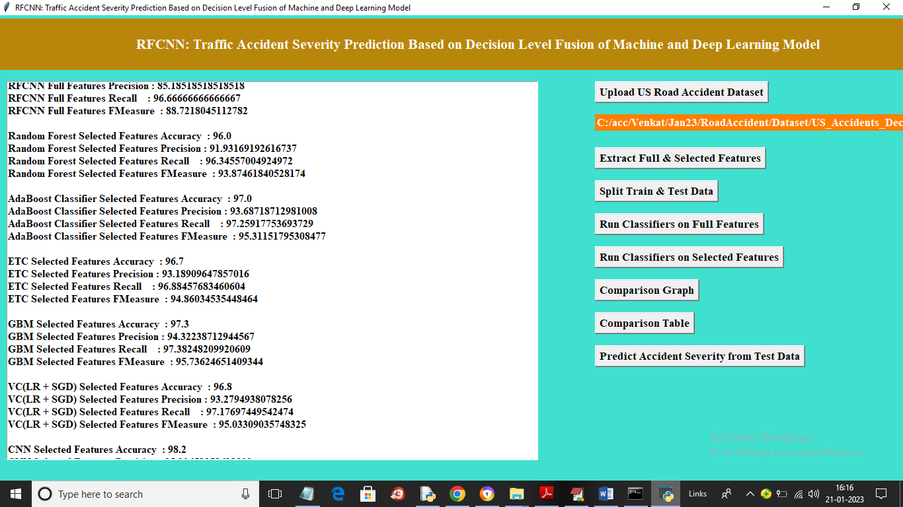

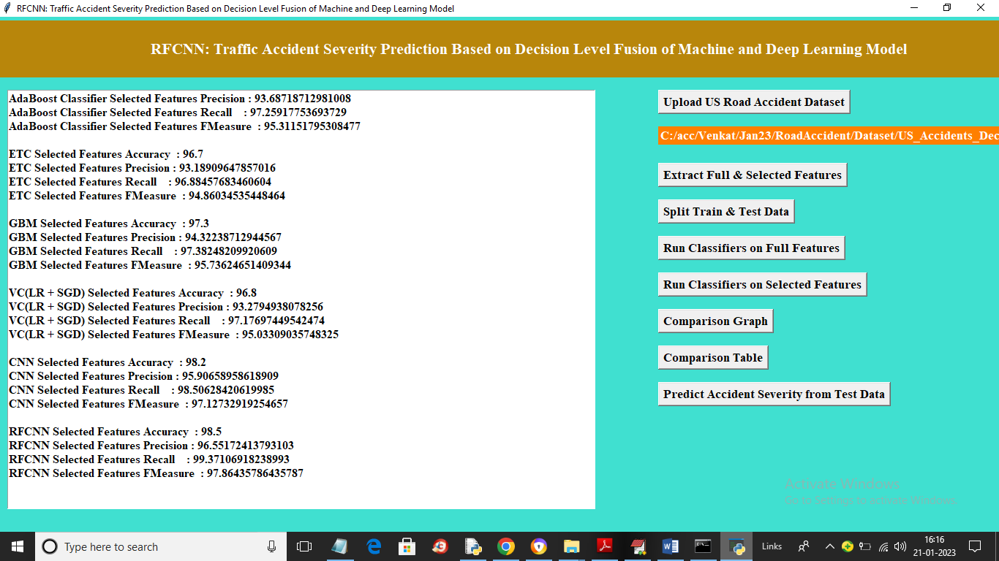

In above screen all algorithm got more than 97% accuracy on selected features and propose RFCNN got high accuracy as 98.50% and now click on ‘Comparison Graph’ button to get below graph

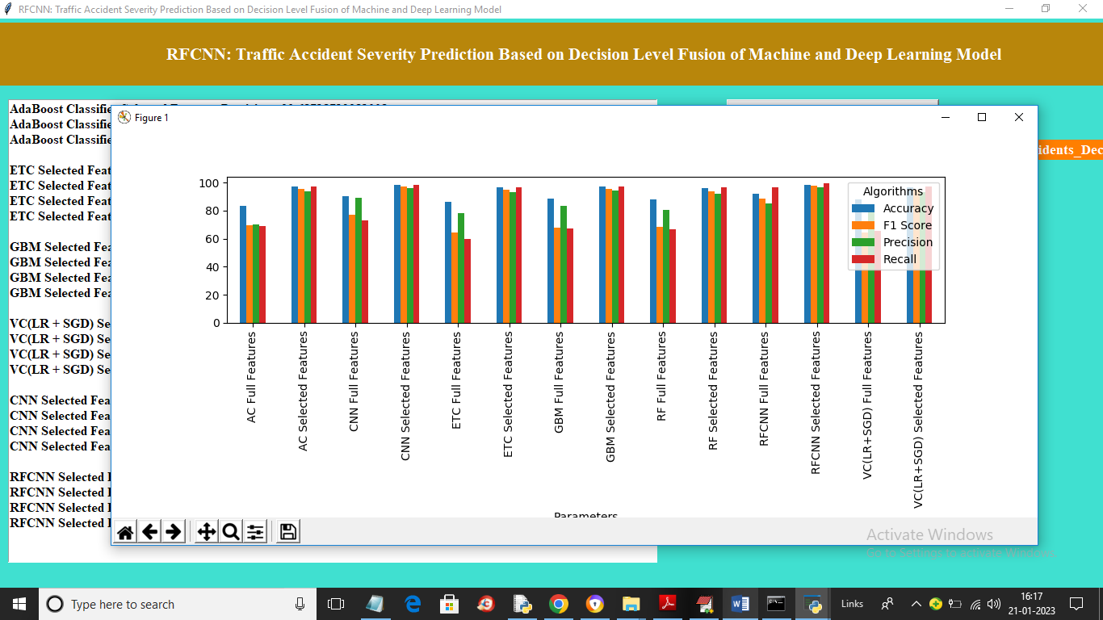

In above graph x-axis represents algorithm names on full and selected features and y-axis represents accuracy and other metrics in different colour bars and in all we can see selected features algorithm got high performance and now click on ‘Comparison Table’ button to get below output

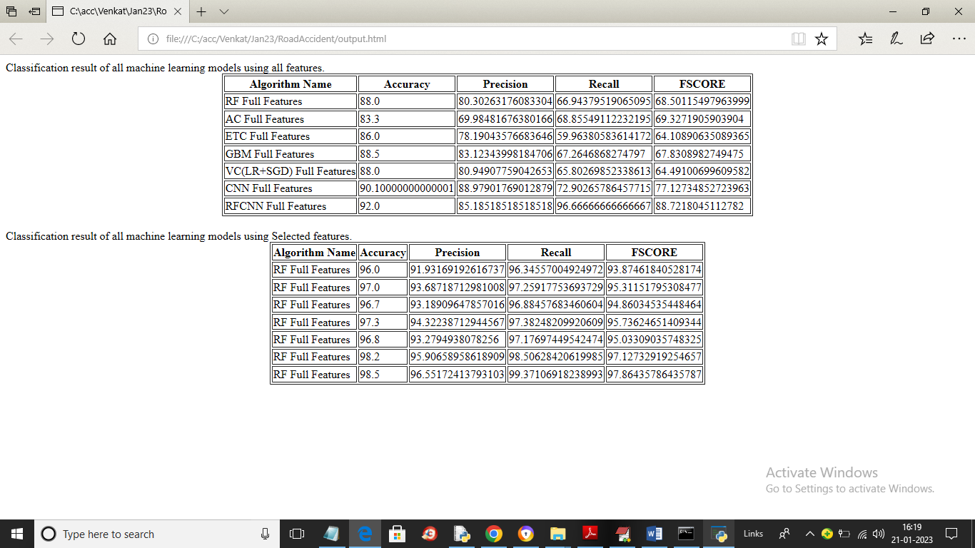

In above screen first table showing accuracy and other metric values on full features and second table showing accuracy on selected features and in both tables we can see Propose RFCCN got high accuracy and now click on ‘Predict Accident Severity from Test Data’ button to upload test data and get below output

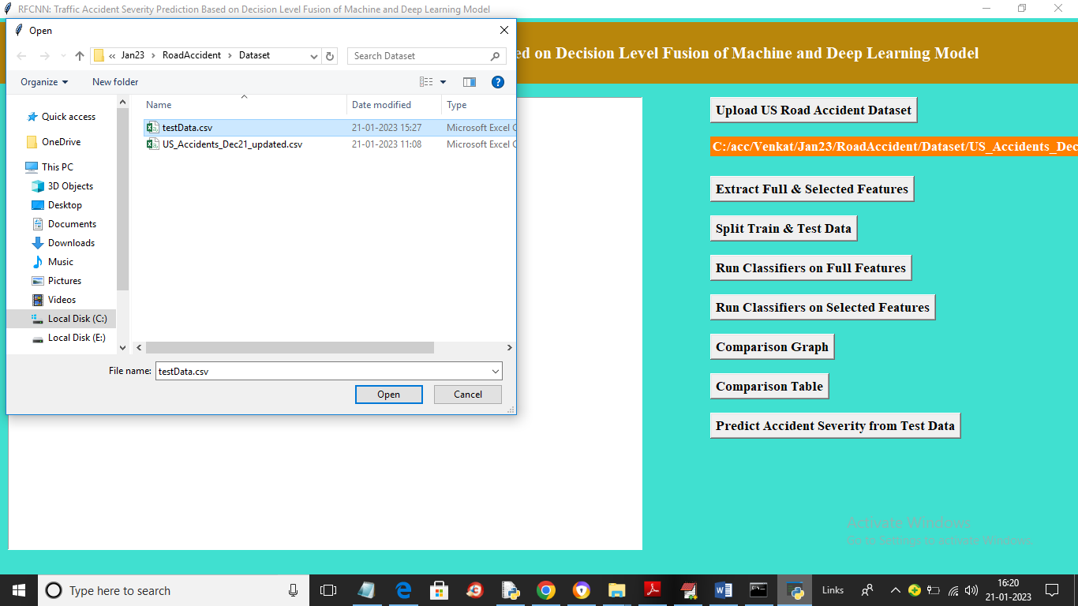

In above screen selecting and uploading ‘TestData.csv’ file and then click on ‘Open’ button to load test data and get below output

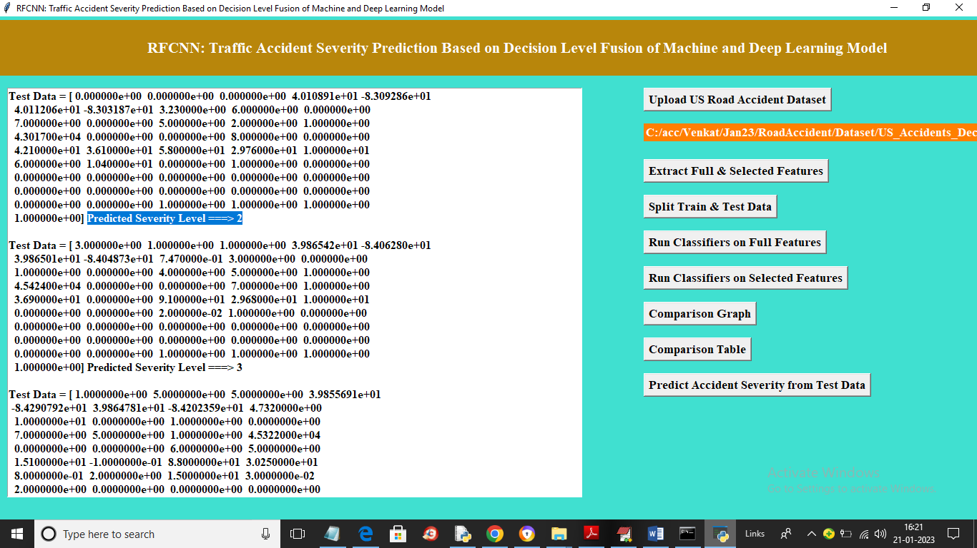

In above screen in square bracket we can see test data and after =🡺 arrow symbol we can see accident severity level as 2 or 3